Task on VPC
1.Create VPC with 2 private and 2 public subnets.
Created a VPC named my-vpc-1 successfully with CIDR block 10.0.0.0/16.
The VPC is in Available state and ready for subnet creation.
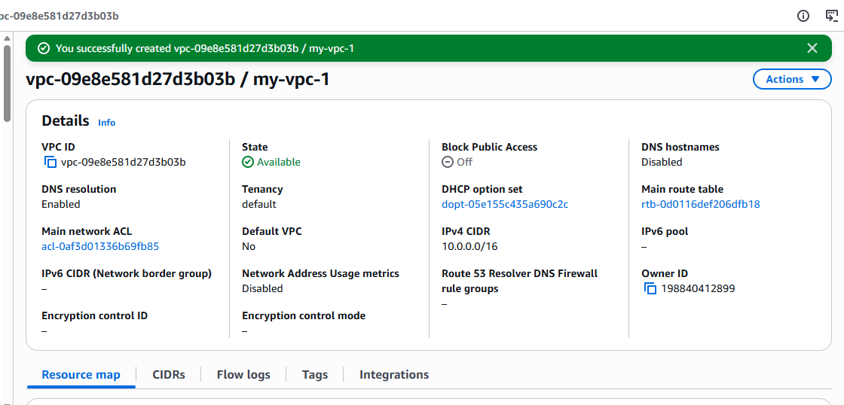
Created 2 public subnets and 2 private subnets successfully inside the VPC.
All subnets are in Available state and ready for route table configuration.
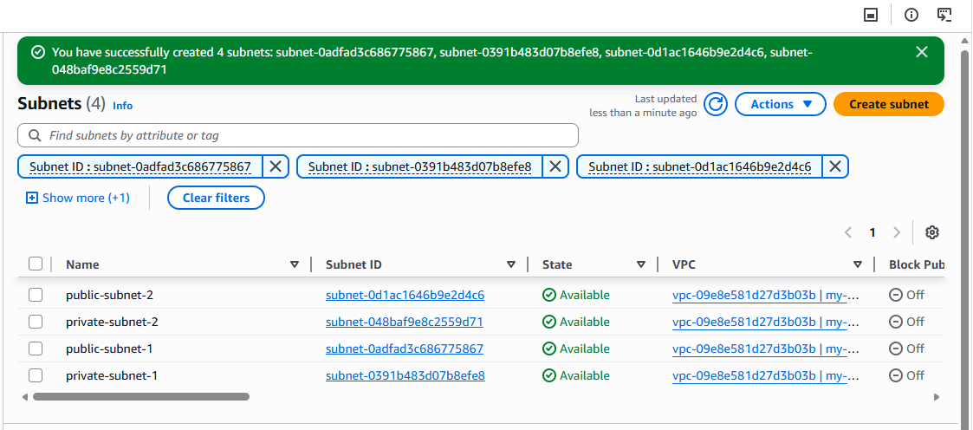

2.Enable DNS Hostname in VPC.
Enabled DNS Hostnames and DNS Resolution in the VPC settings successfully.

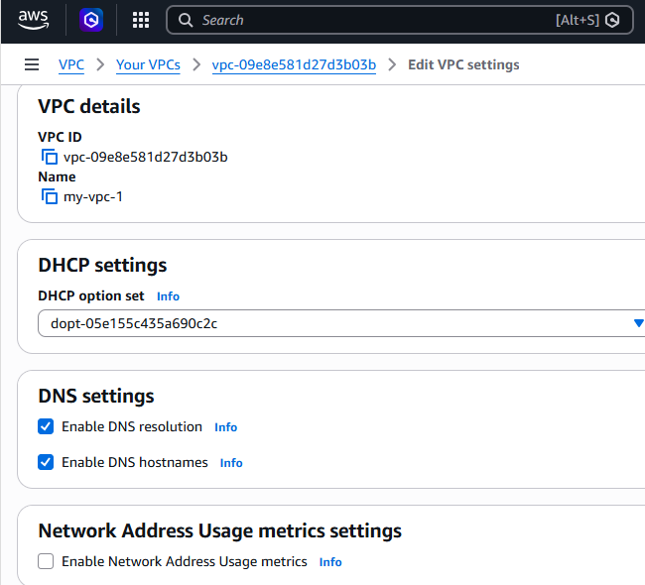

3. Enable Auto Assign Public IP in 2 public subnets.
Opened the settings of public-subnet-1 and modified the subnet configuration.
Enabled Auto-assign Public IPv4 address for the public subnet successfully.
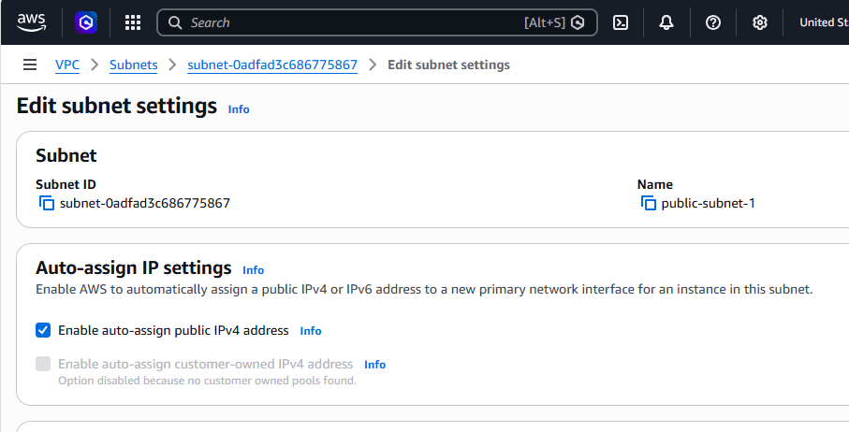
Opened the settings of public-subnet-2 and updated the subnet configuration.
Enabled Auto-assign Public IPv4 address for the second public subnet successfully.
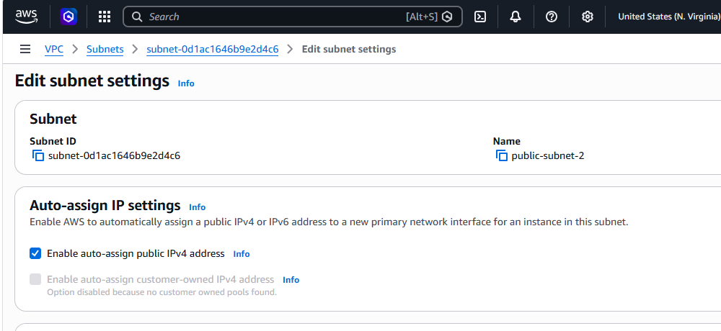

4. Add 2 private subnets in private route table.
Created a new route table named private-round-table inside the selected VPC.
The private route table was created successfully with the default local route.
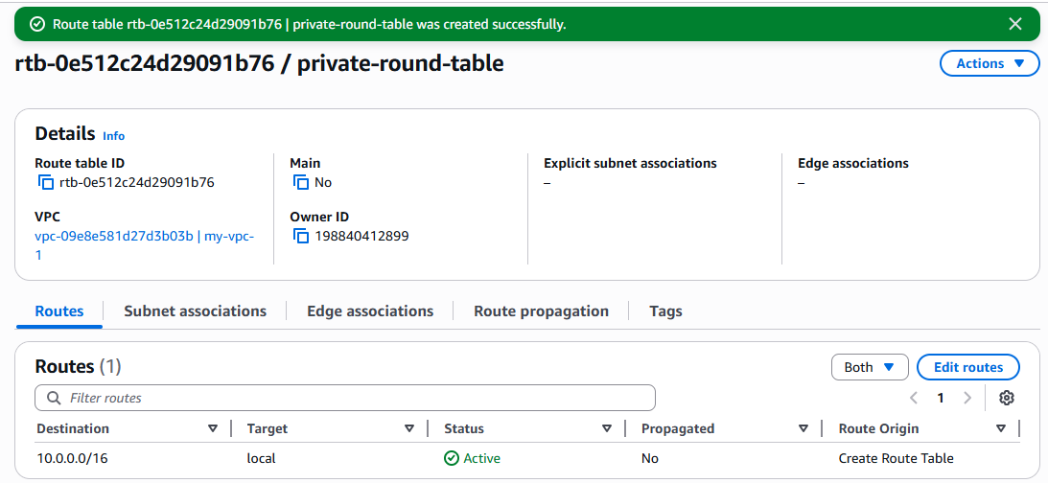
Opened the private-round-table and edited the subnet associations.
Associated private-subnet-1 and private-subnet-2 with the private route table successfully.
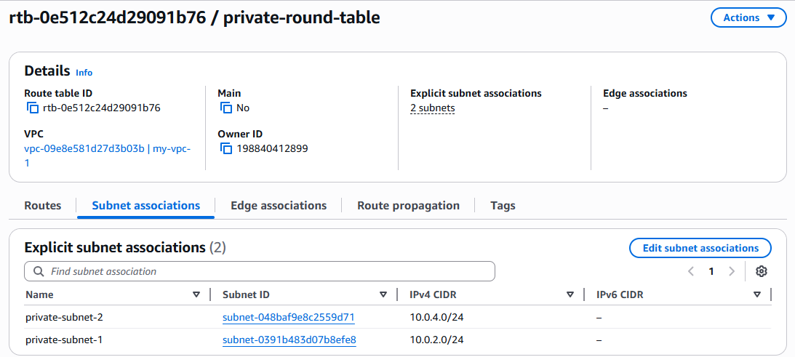

5. Add 2 public subnets in public route table.
Created a new route table named public-round-table inside the selected VPC.
The public route table was created successfully with the default local route.
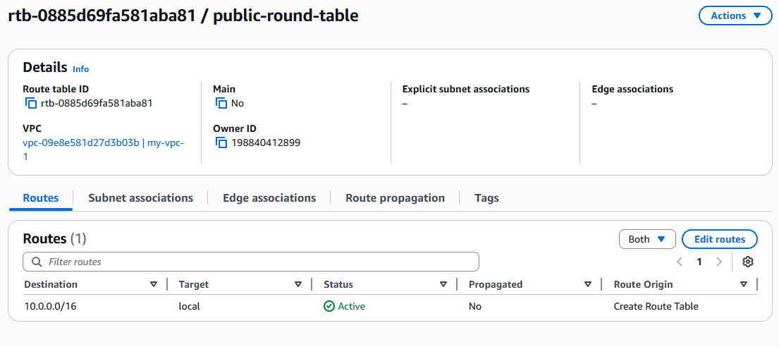
Opened the public-round-table and edited the subnet associations.
Associated public-subnet-1 and public-subnet-2 with the public route table successfully.

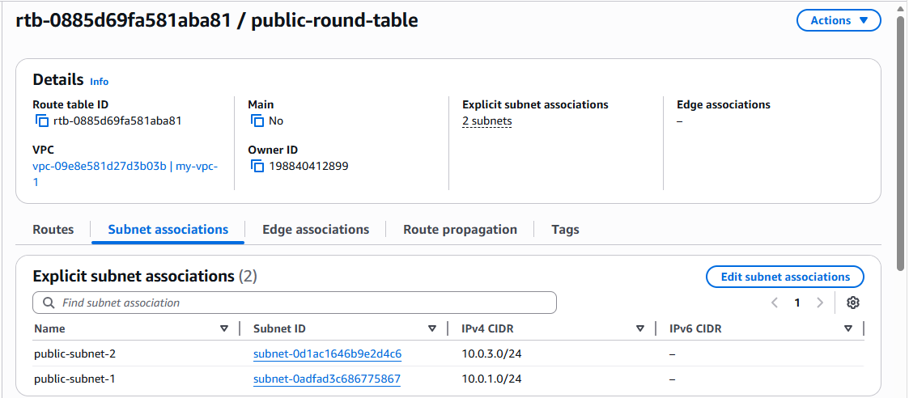

6. Public route table will have the routes to internet and local.
Opened the public-round-table and viewed the configured routes.
The route table contains local route (10.0.0.0/16) and internet route (0.0.0.0/0) through the Internet.
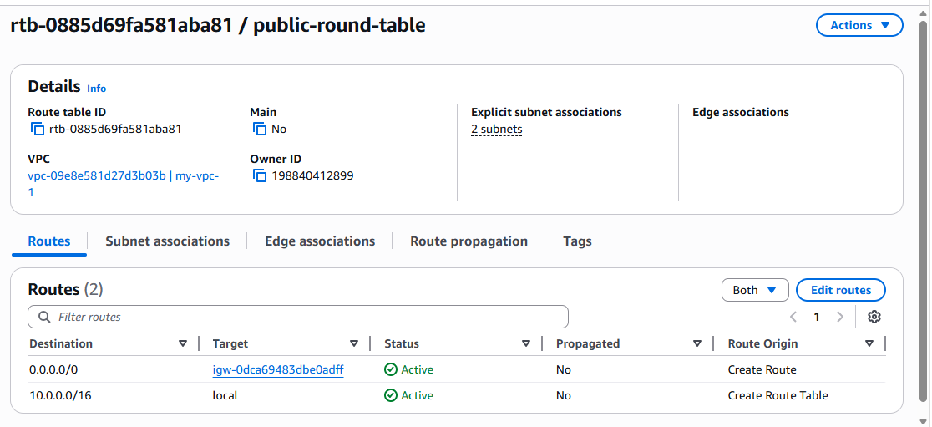

7. Create EC2 in public subnet with t2.micro and install PHP.
Opened the EC2 launch wizard and configured the network settings for my-vpc-1.
Selected public-subnet-1 and enabled Auto-assign Public IP for the instance.
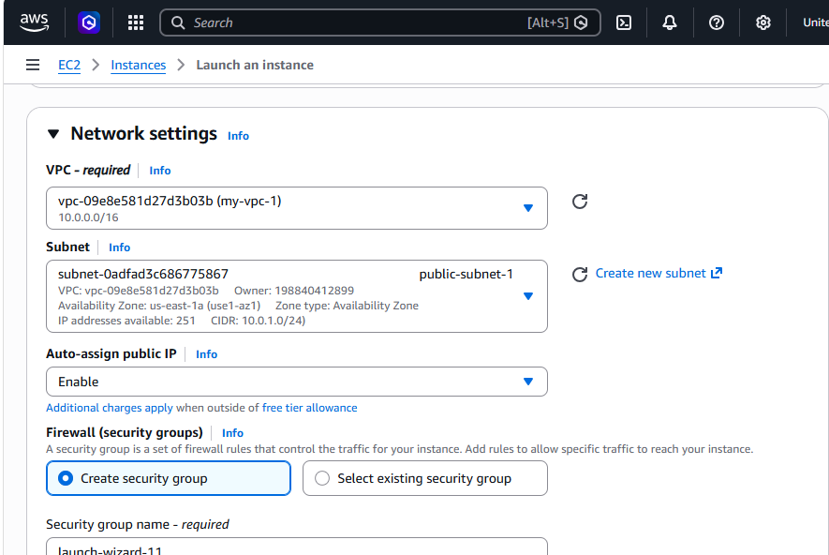
Connected to the EC2 instance using SSH from the local system successfully.
Ran the commands to update packages and install PHP on the instance.
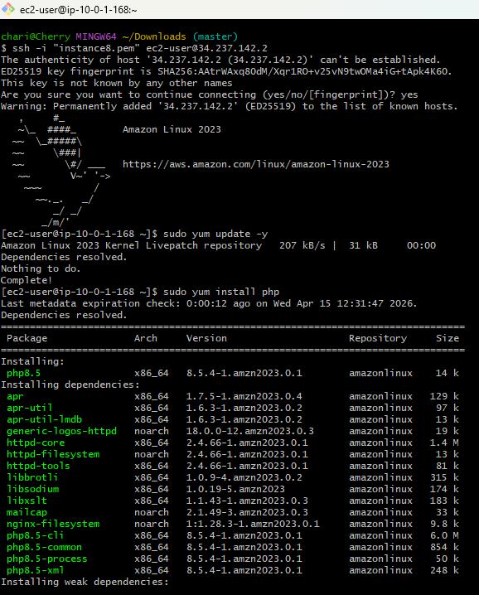
Executed the PHP installation command on the EC2 instance and completed the setup successfully.
All required PHP packages and dependencies were installed on the server.
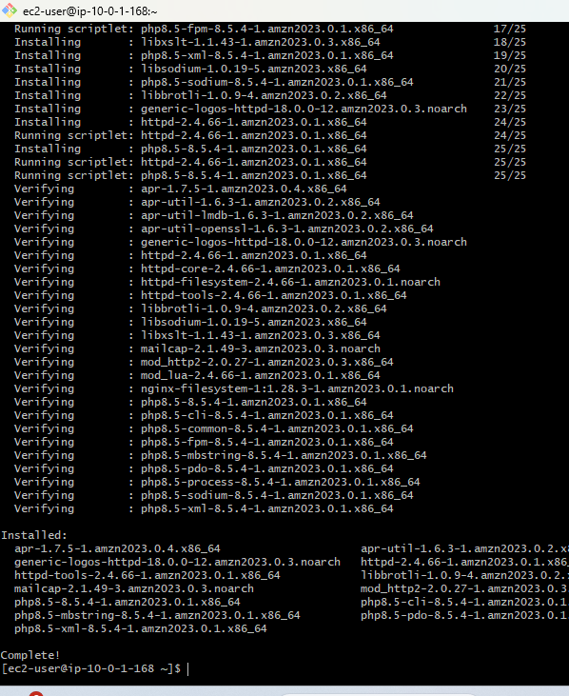

8. Configure NAT gateway in public subnet and connect to private instance.
Created a NAT Gateway named private-nat-gateway in the public subnet with an Elastic IP.
Configured it to provide internet access for instances running in the private subnets.
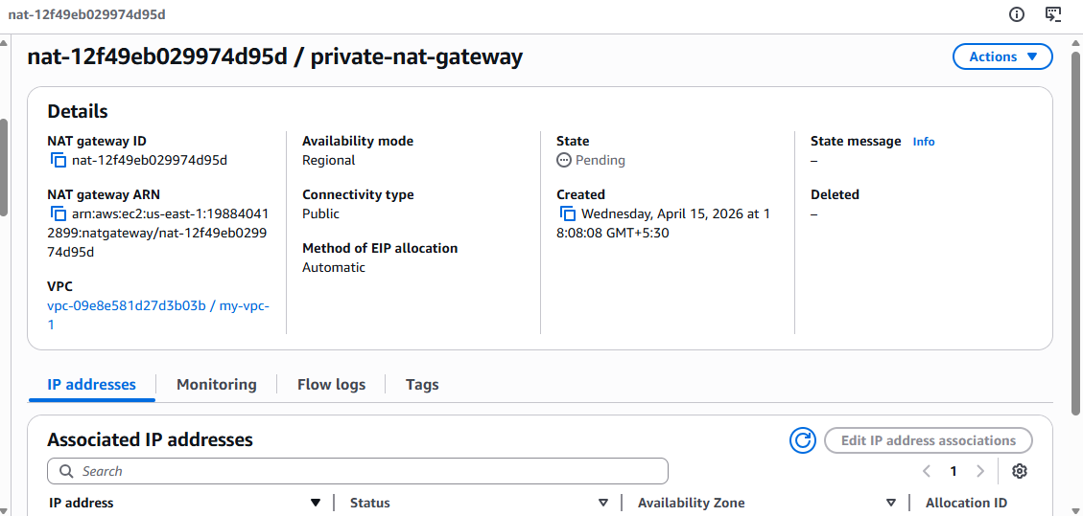
Opened the private-round-table and updated the route configuration.
Added the 0.0.0.0/0 route to the NAT Gateway for private subnet internet access.
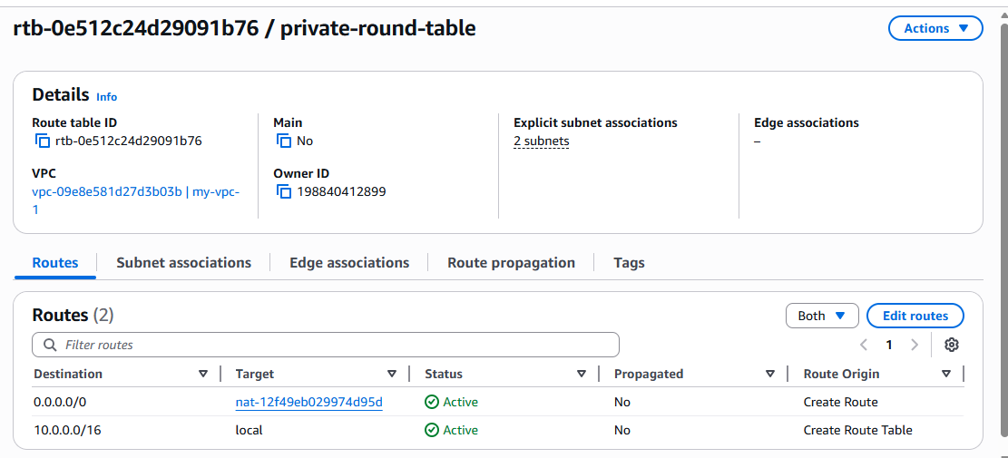
Connected to the public EC2 instance using SSH from the local machine successfully.
Copied the key file content to use secure access for connecting to the private instance.
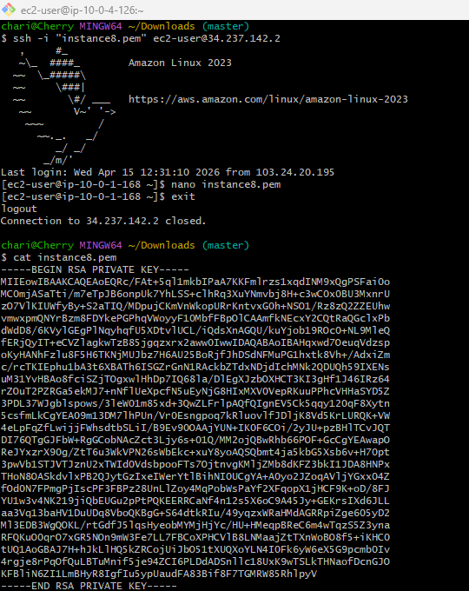
Logged in to the public instance and updated the key file permissions using chmod 700.
Connected from the public instance to the private EC2 instance using its private IP successfully.

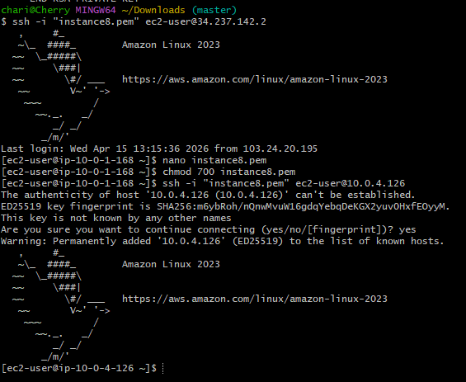

9. Install Apache Tomcat in private EC2 and deploy a sample app.
Connected to the private EC2 instance and switched to the root user.
Executed the command to install Java, which is required for Apache Tomcat setup.

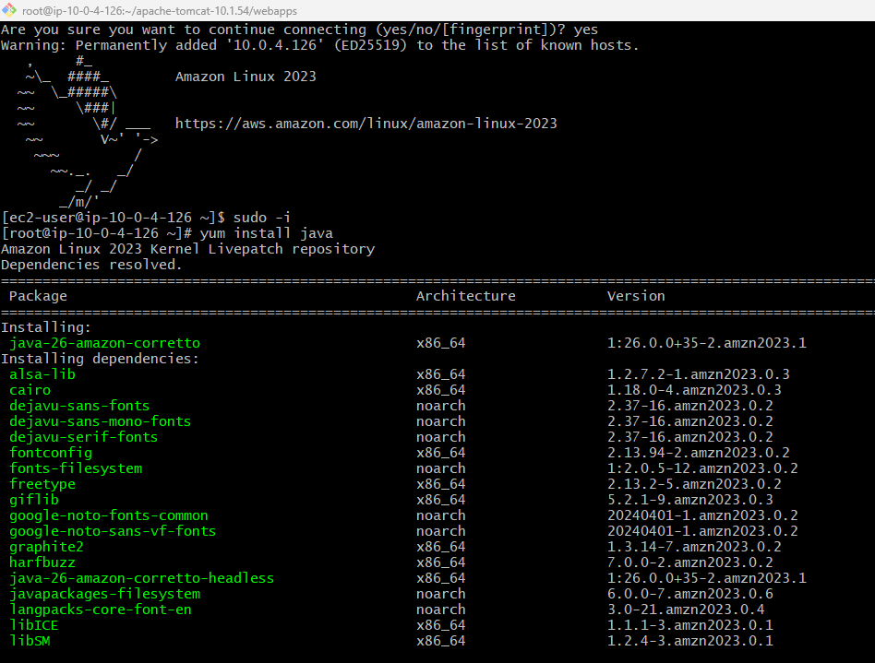
Verified the Java installation and downloaded the Apache Tomcat package on the private instance.
Extracted the Tomcat archive successfully to begin application deployment.

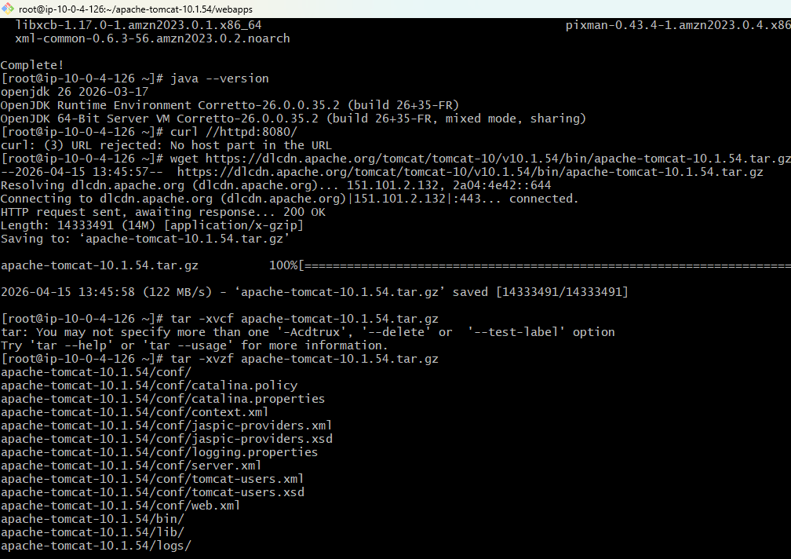
Navigated to the Tomcat bin directory and started the Tomcat server using startup.sh.
Verified the installation by accessing http://localhost:8080 and viewing the Tomcat default page.
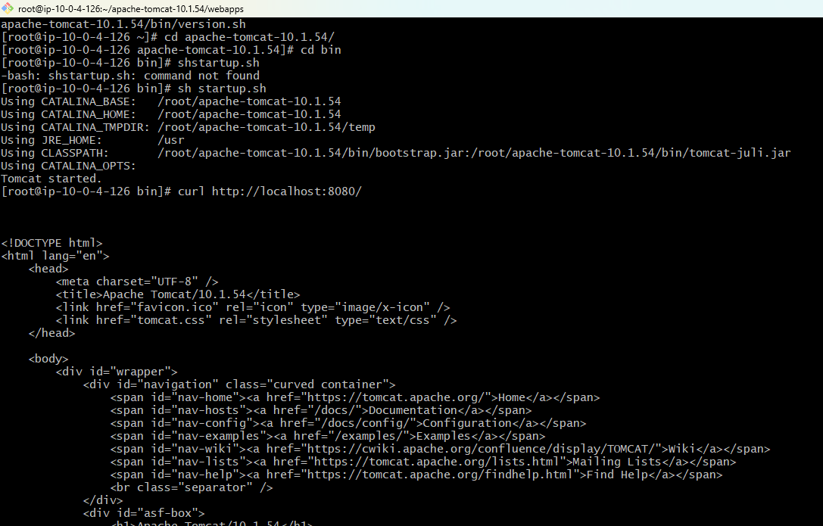
Moved to the Tomcat webapps folder and downloaded the sample application sample.war.
Deployed the application successfully and verified it using http://localhost:8080/sample/.
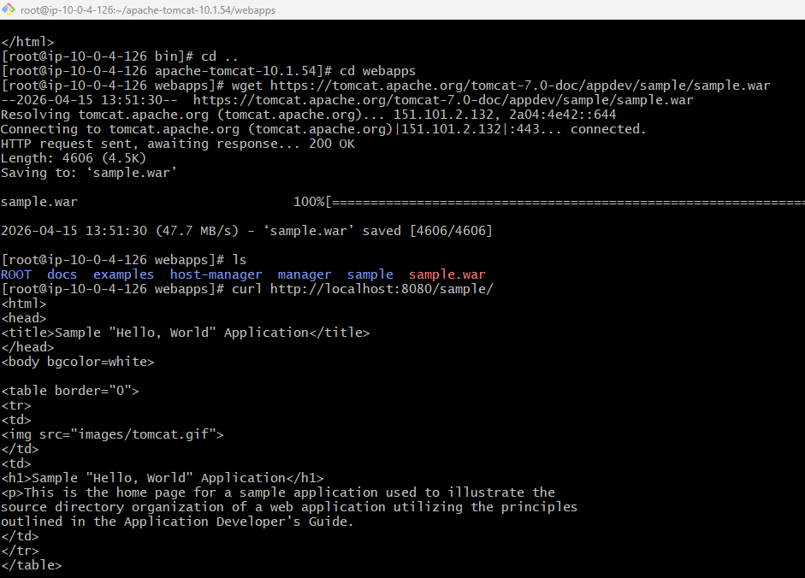
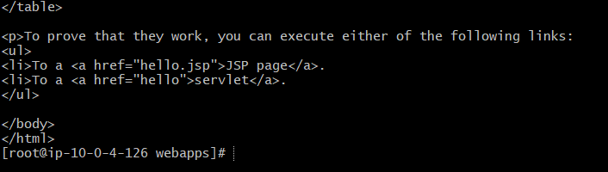

10. Configure VPC flow logs and store the logs in S3 and CloudWatch.
Created an Amazon S3 bucket named cherrybuckets3 successfully for storing VPC Flow Logs.
This bucket will be used as the destination to save network traffic log files.
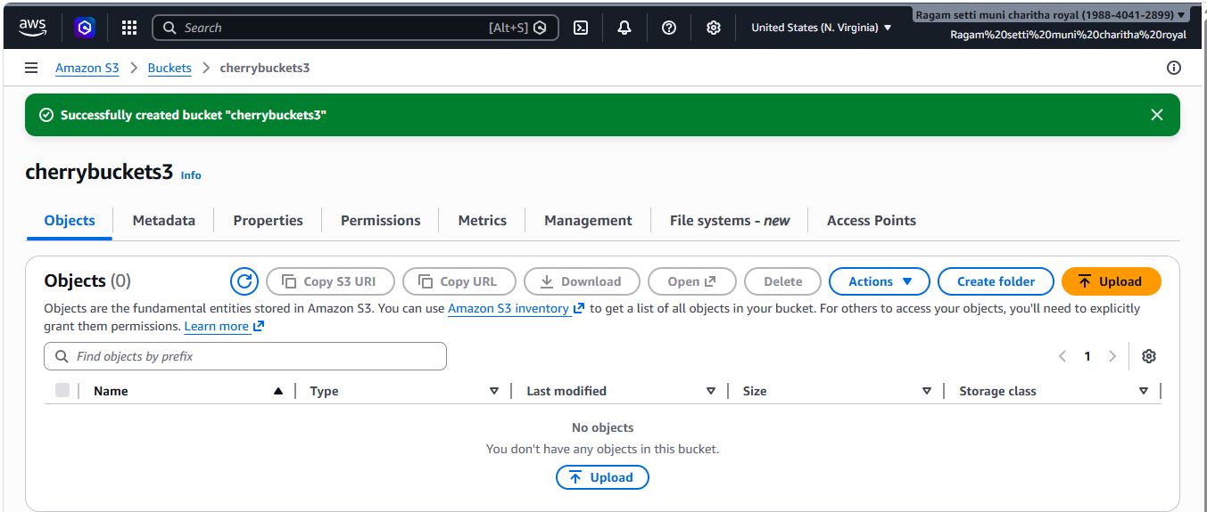
Opened the VPC Create Flow Logs settings and selected the destination as Amazon S3 using the bucket ARN.
Created VPC Flow Logs successfully and configured log delivery to both S3 and CloudWatch Logs.

